**Lab – 8**

18MIS7250

Amit Kumar Sahu

**WAN configuration using static ip addressing**

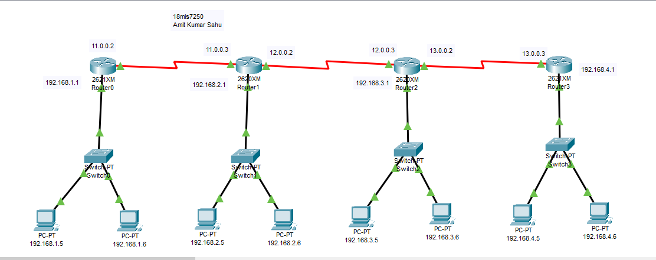

Configuring route for Router 1

Router(config)#

Router(config)#ip route 192.168.3.0 255.255.255.0 11.0.0.3

Router(config)#ip route 192.168.4.0 255.255.255.0 11.0.0.3

Router(config)#ip route 12.0.0.0 255.0.0.0 11.0.0.3

Router(config)#ip route 13.0.0.0 255.0.0.0 12.0.0.3

Router(config)#

Configuring route for Router 2

Router(config)#ip route 192.168.3.0 255.255.255.0 12.0.0.3

Router(config)#ip route 192.168.4.0 255.255.255.0 12.0.0.3

Router(config)#ip route 13.0.0.0 255.0.0.0 12.0.0.3

Router(config)#

Configuring route for Router 3

Router(config)#ip route 192.168.2.0 255.255.255.0 12.0.0.2

Router(config)#ip route 192.168.1.0 255.255.255.0 12.0.0.2

Router(config)#ip route 192.168.4.0 255.255.255.0 13.0.0.3

Router(config)#ip route 11.0.0.0 255.0.0.0 12.0.0.2

Router(config)

Configuring route for Router 4

Router(config)#

Router(config)#ip route 192.168.3.0 255.255.255.0 13.0.0.2

Router(config)#ip route 192.168.2.0 255.255.255.0 13.0.0.2

Router(config)#ip route 192.168.1.0 255.255.255.0 13.0.0.2

Router(config)#ip route 11.0.0.0 255.0.0.0 12.0.0.2

Router(config)#ip route 12.0.0.0 255.0.0.0 13.0.0.2

Router(config)#

Checking connections by pinging

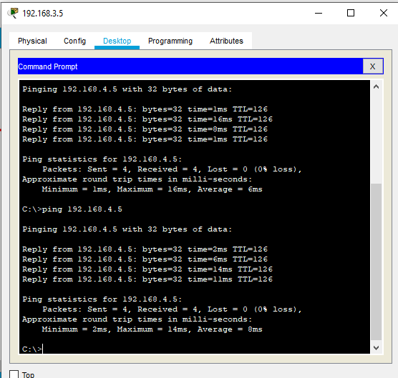

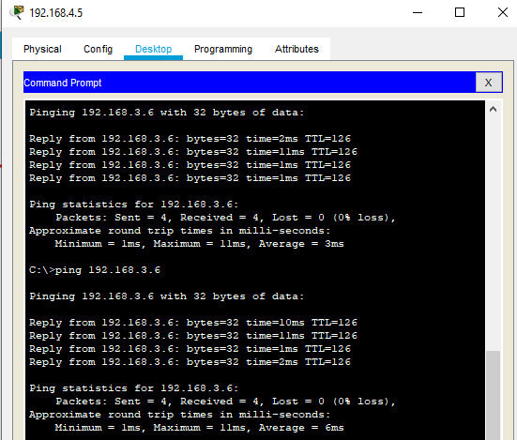

Pinging from192.168.1.5 to 192.168.3.6

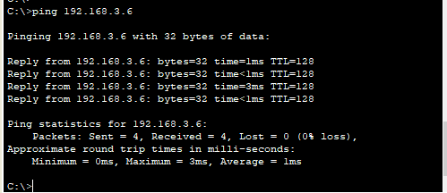

Pinging from192.168.4.6 to 192.168.1.6

